**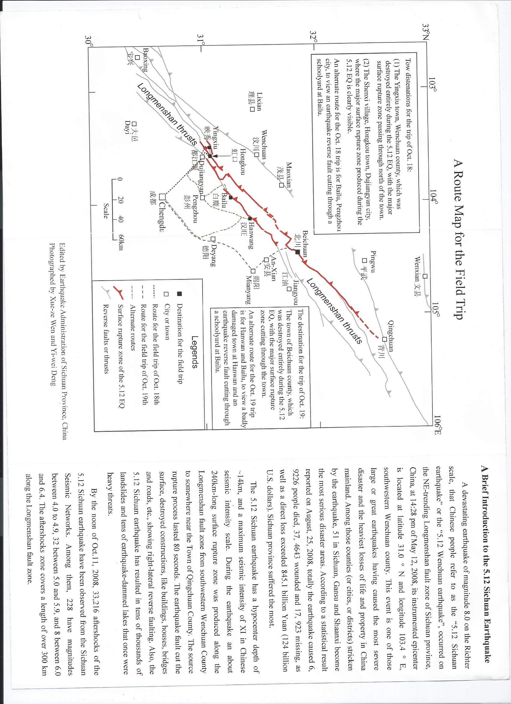**

**Yingxiu**

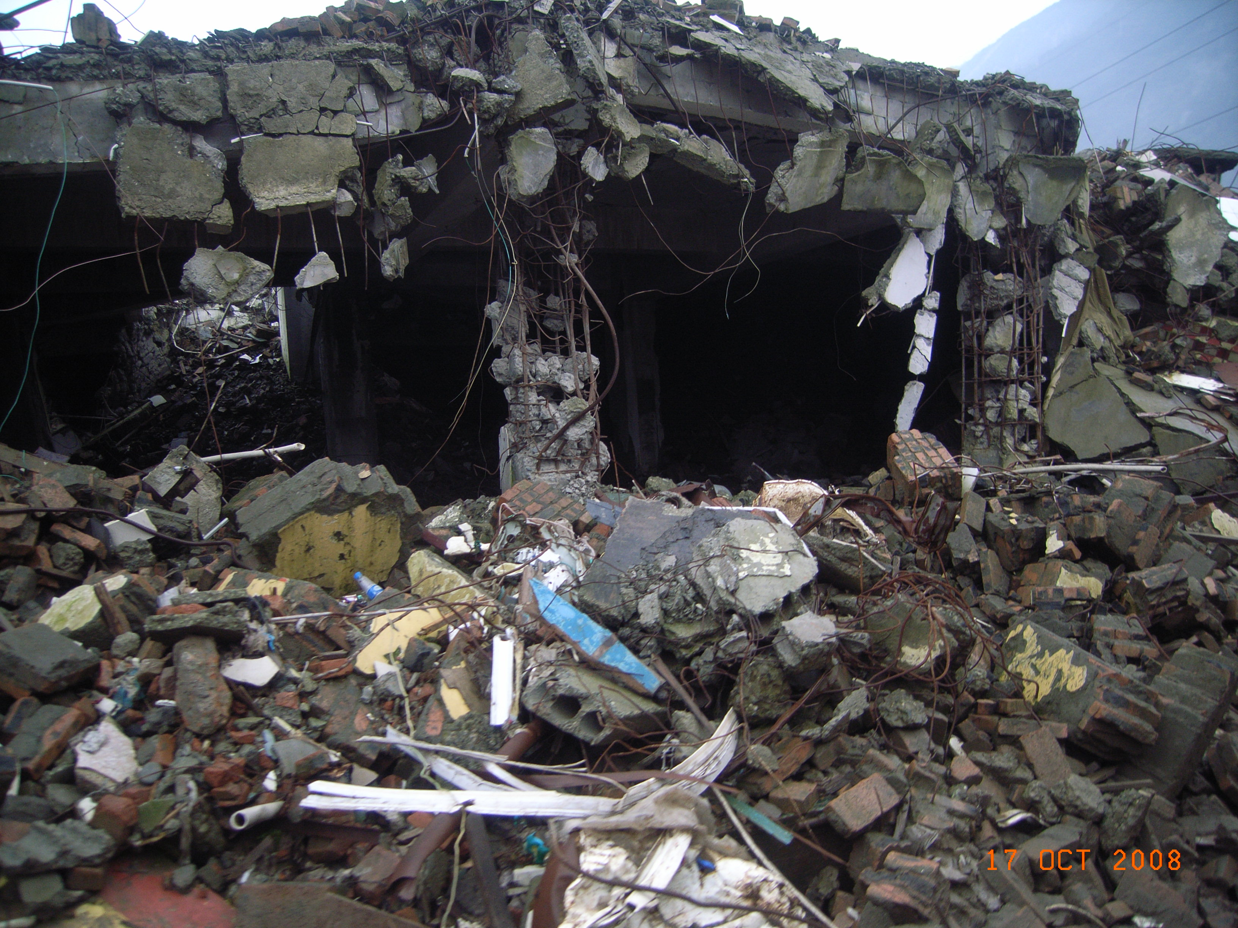

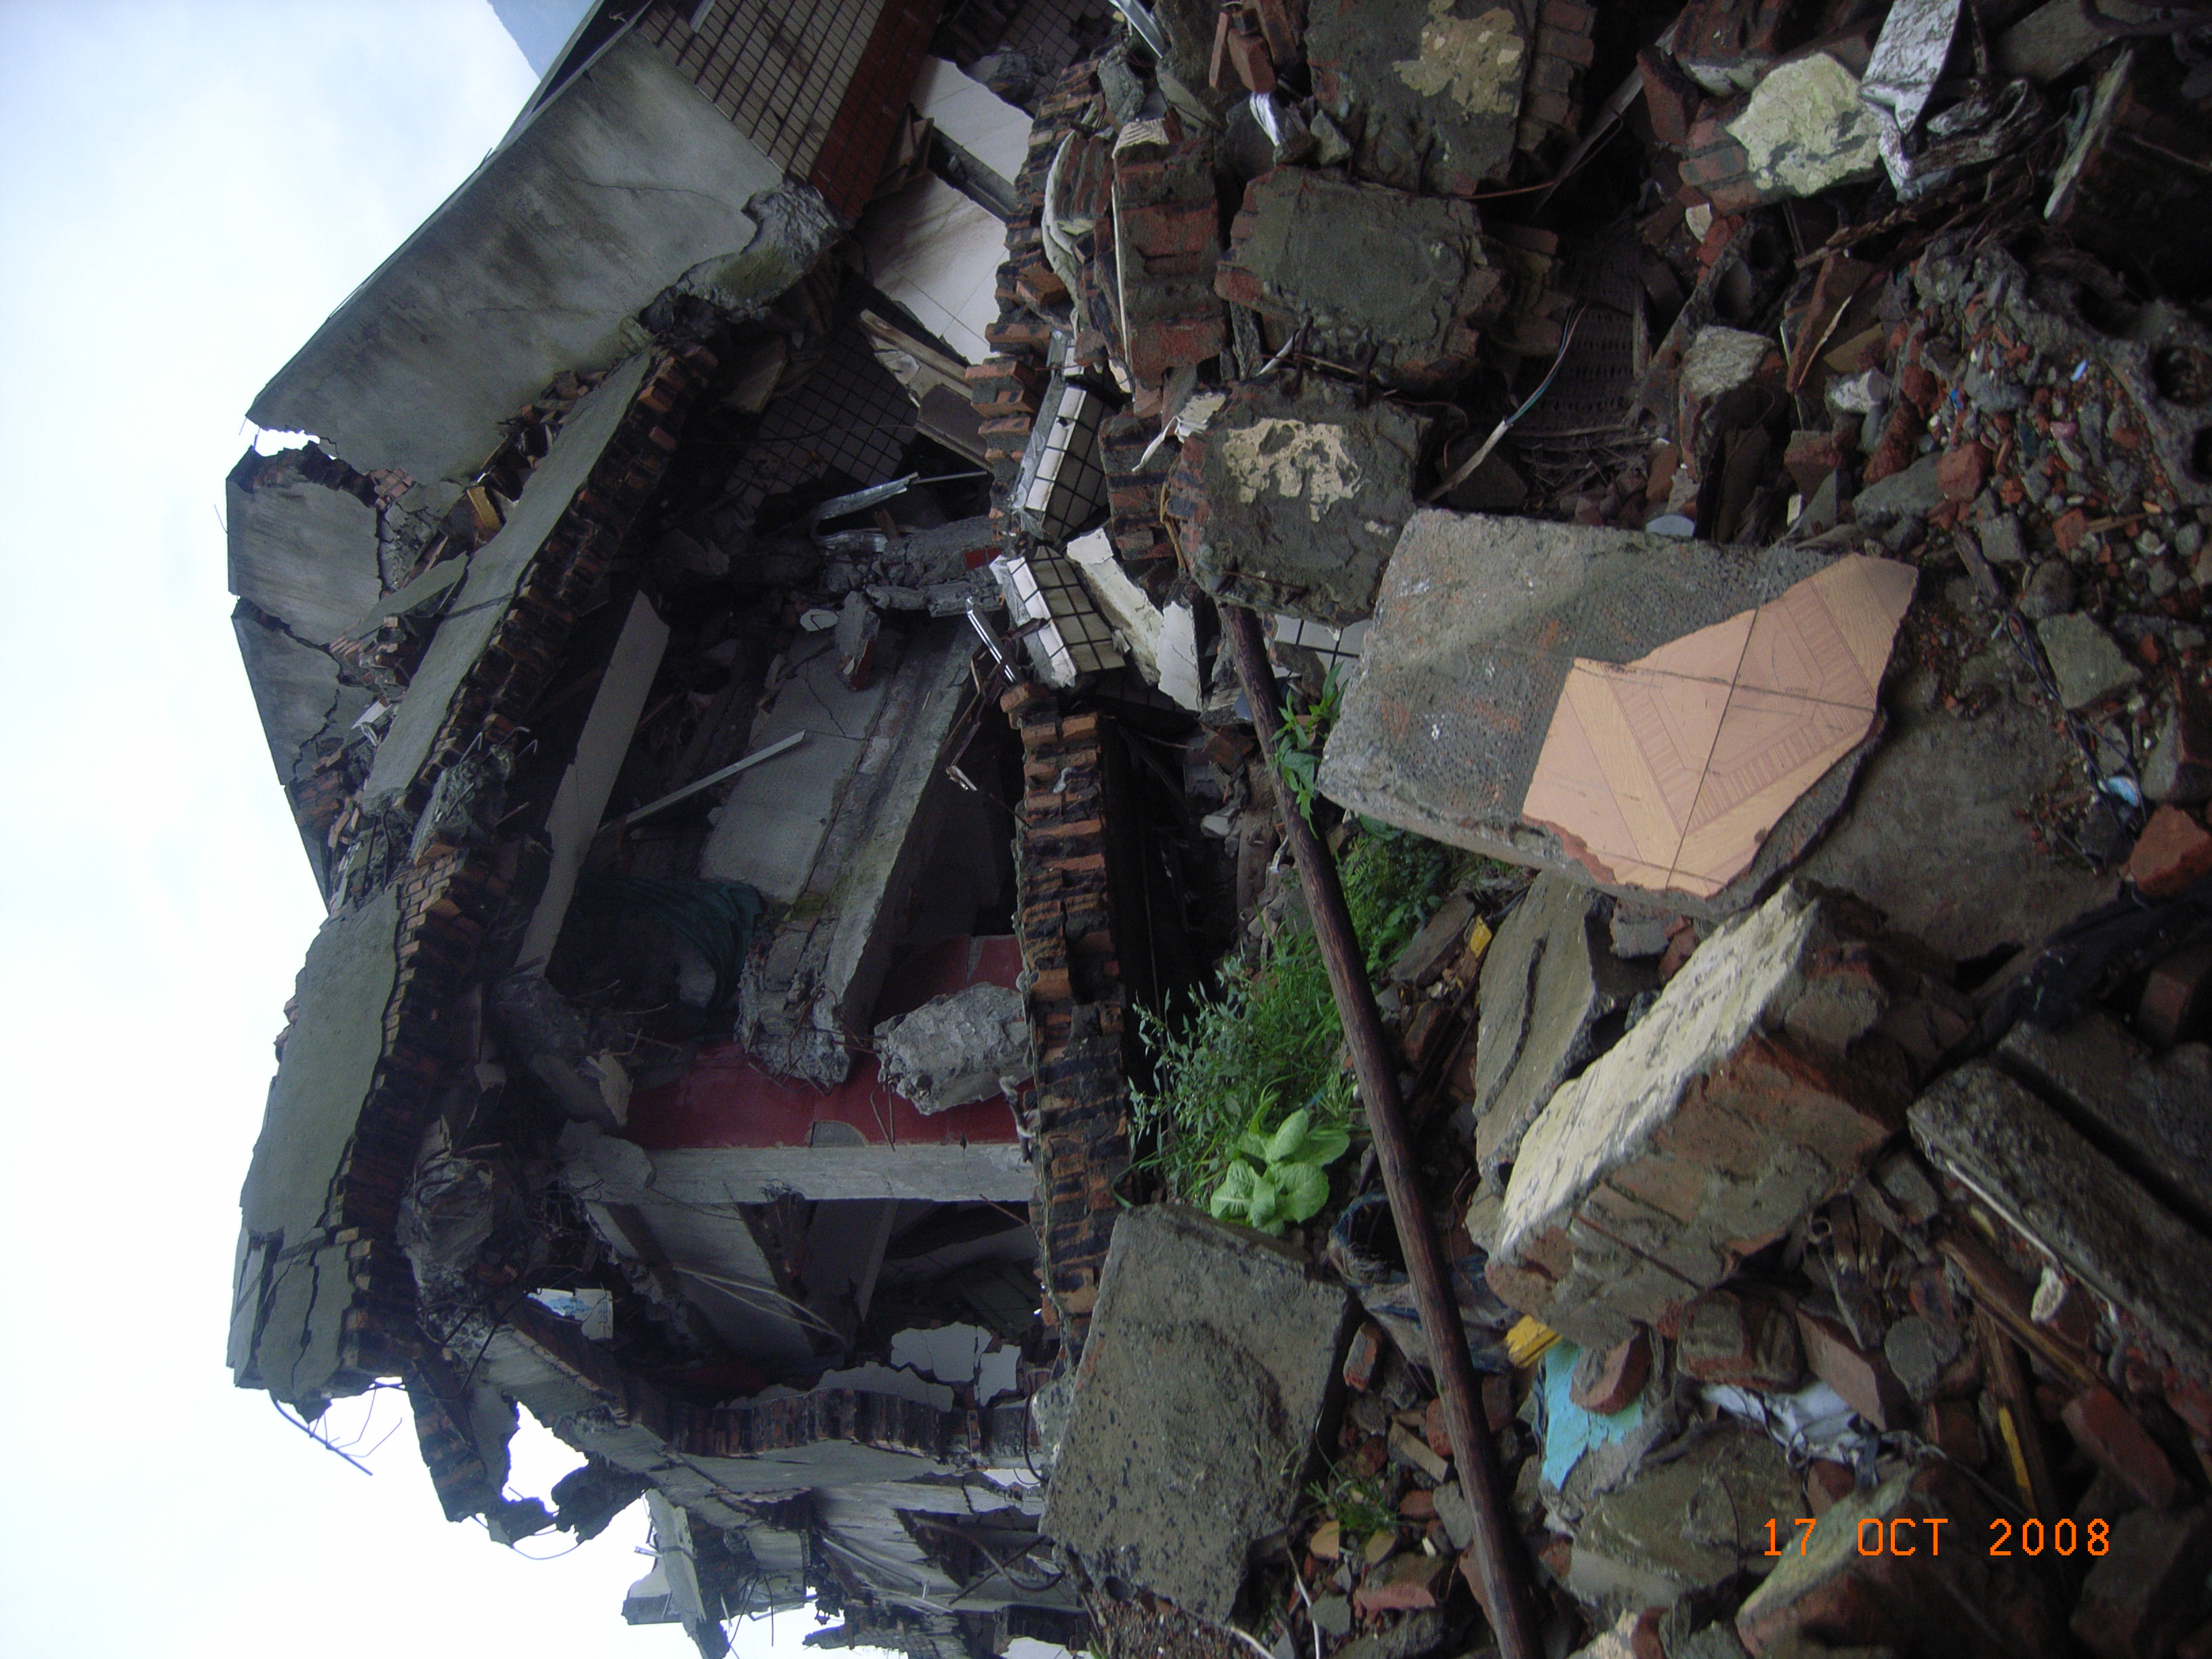

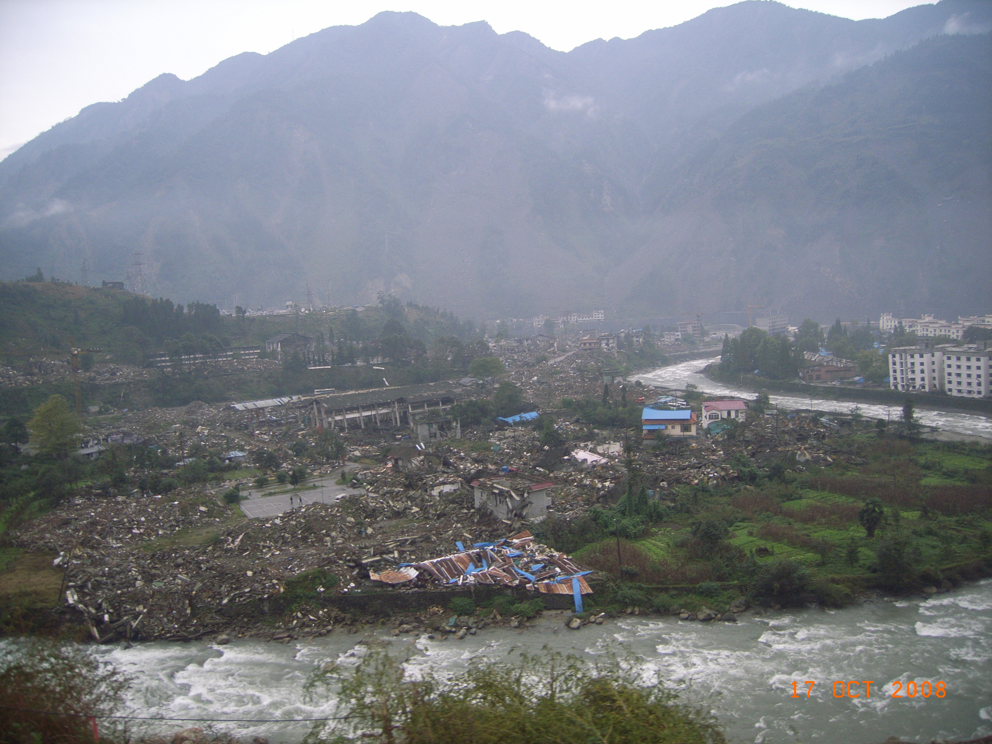

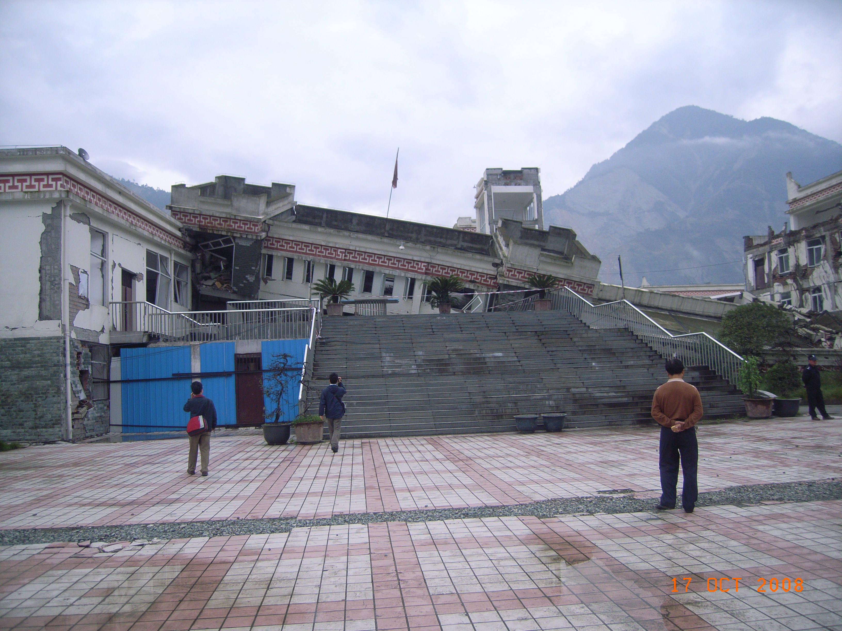

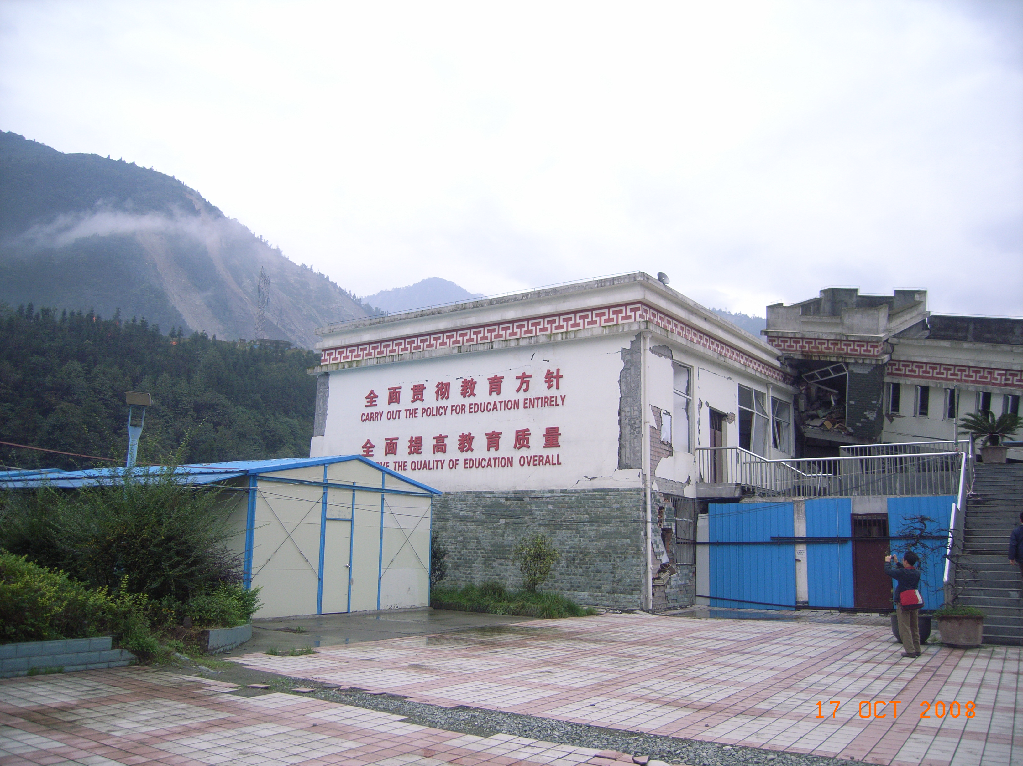

**Bailu**

**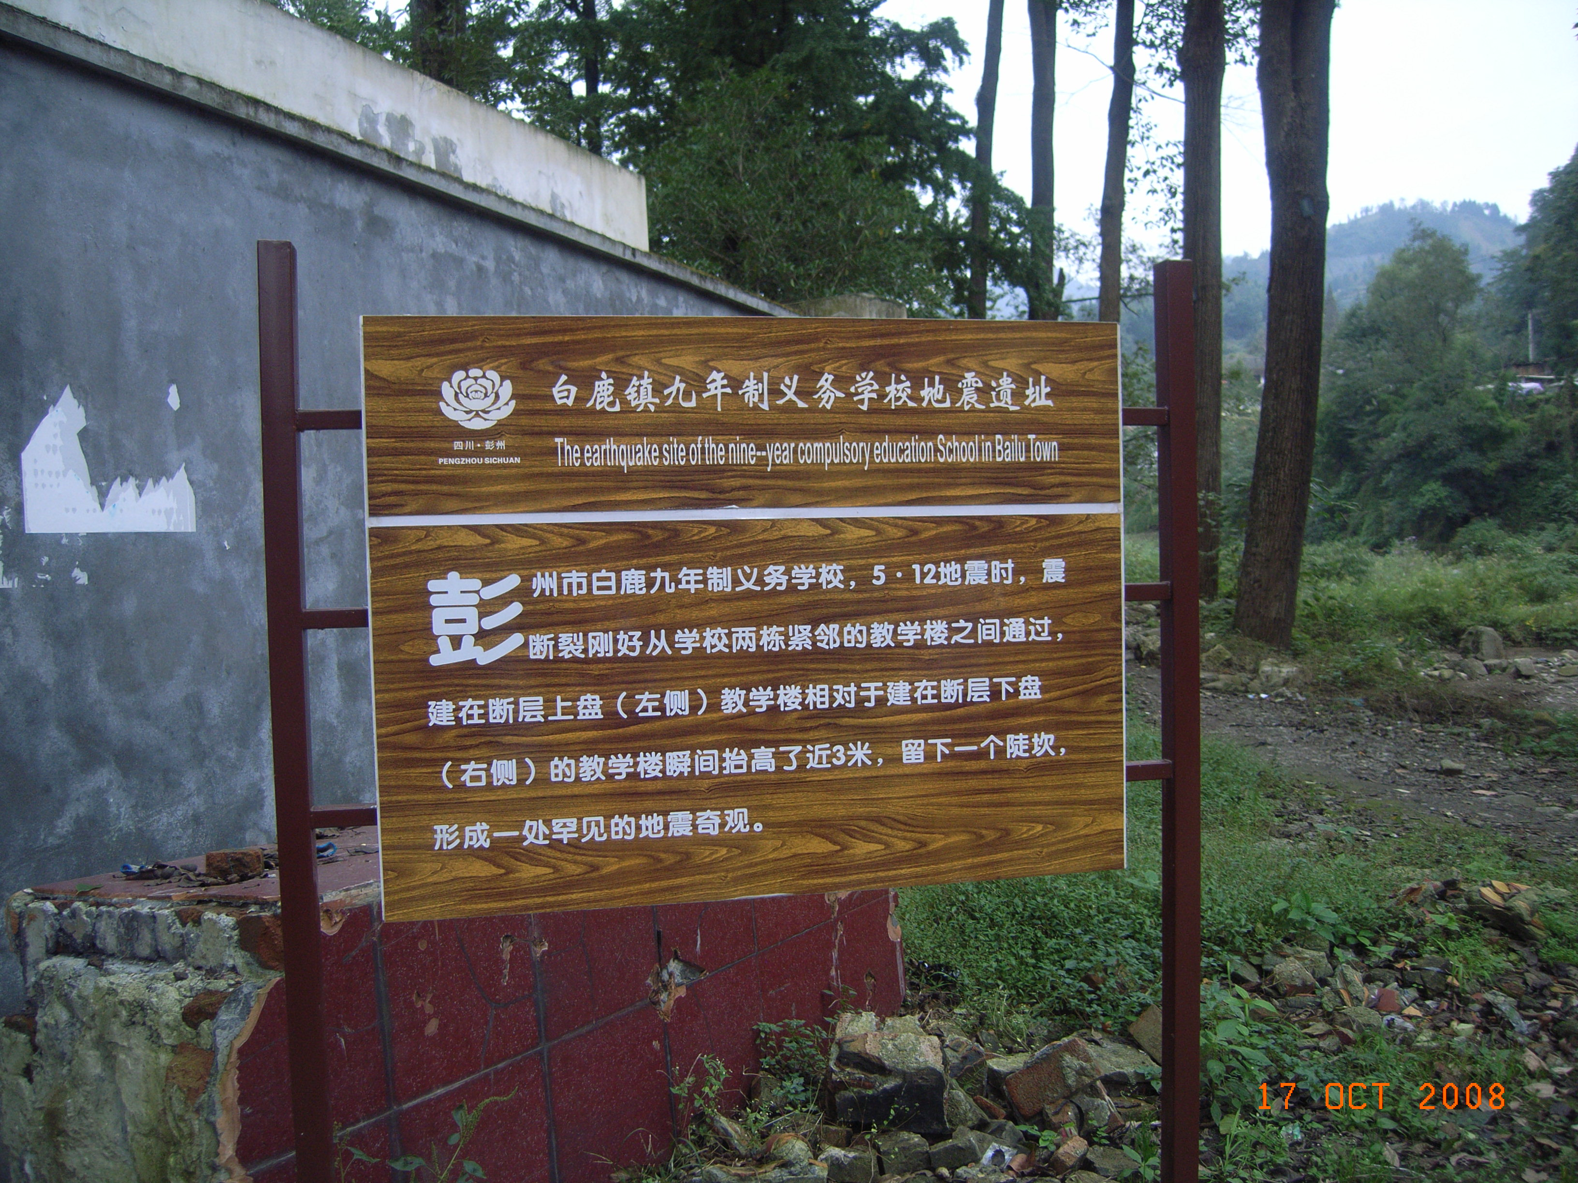**

**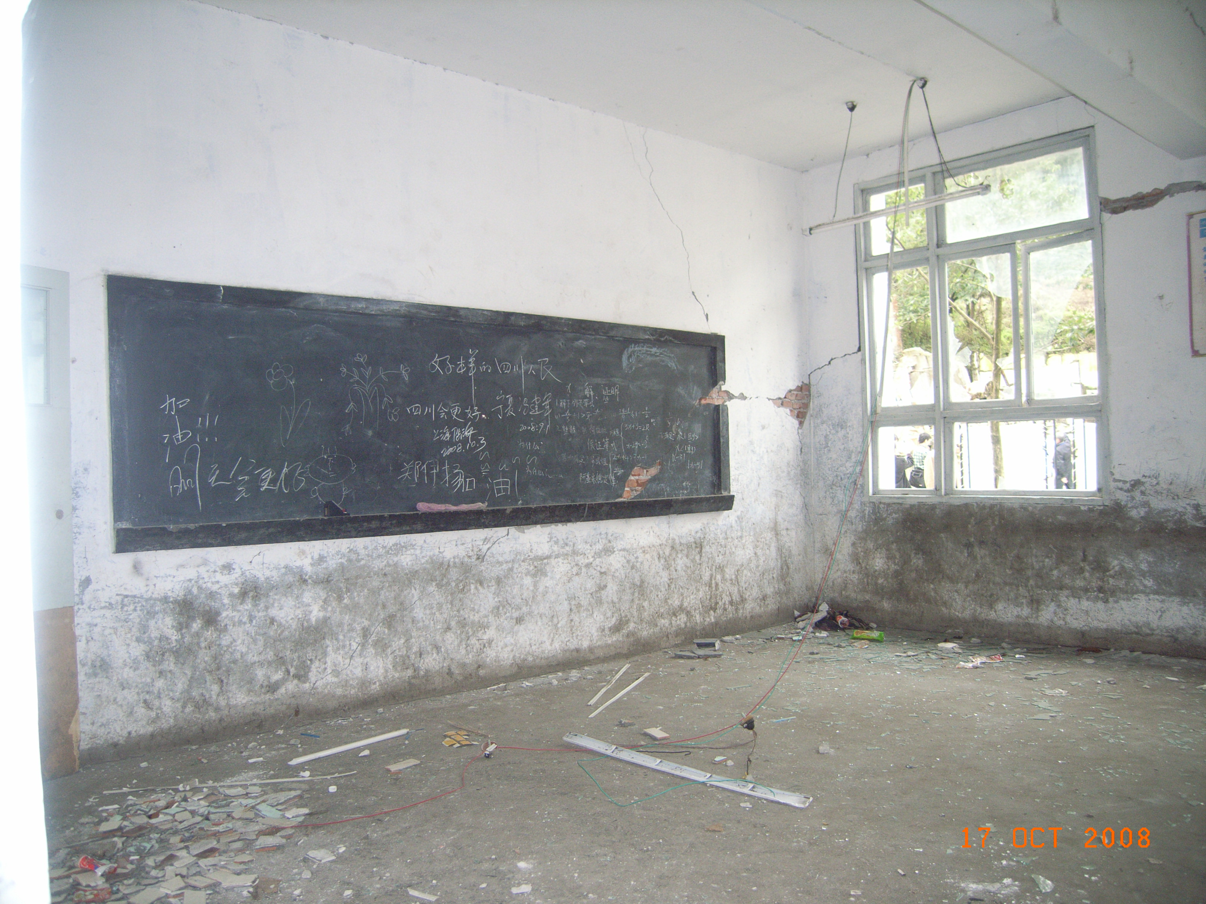**

**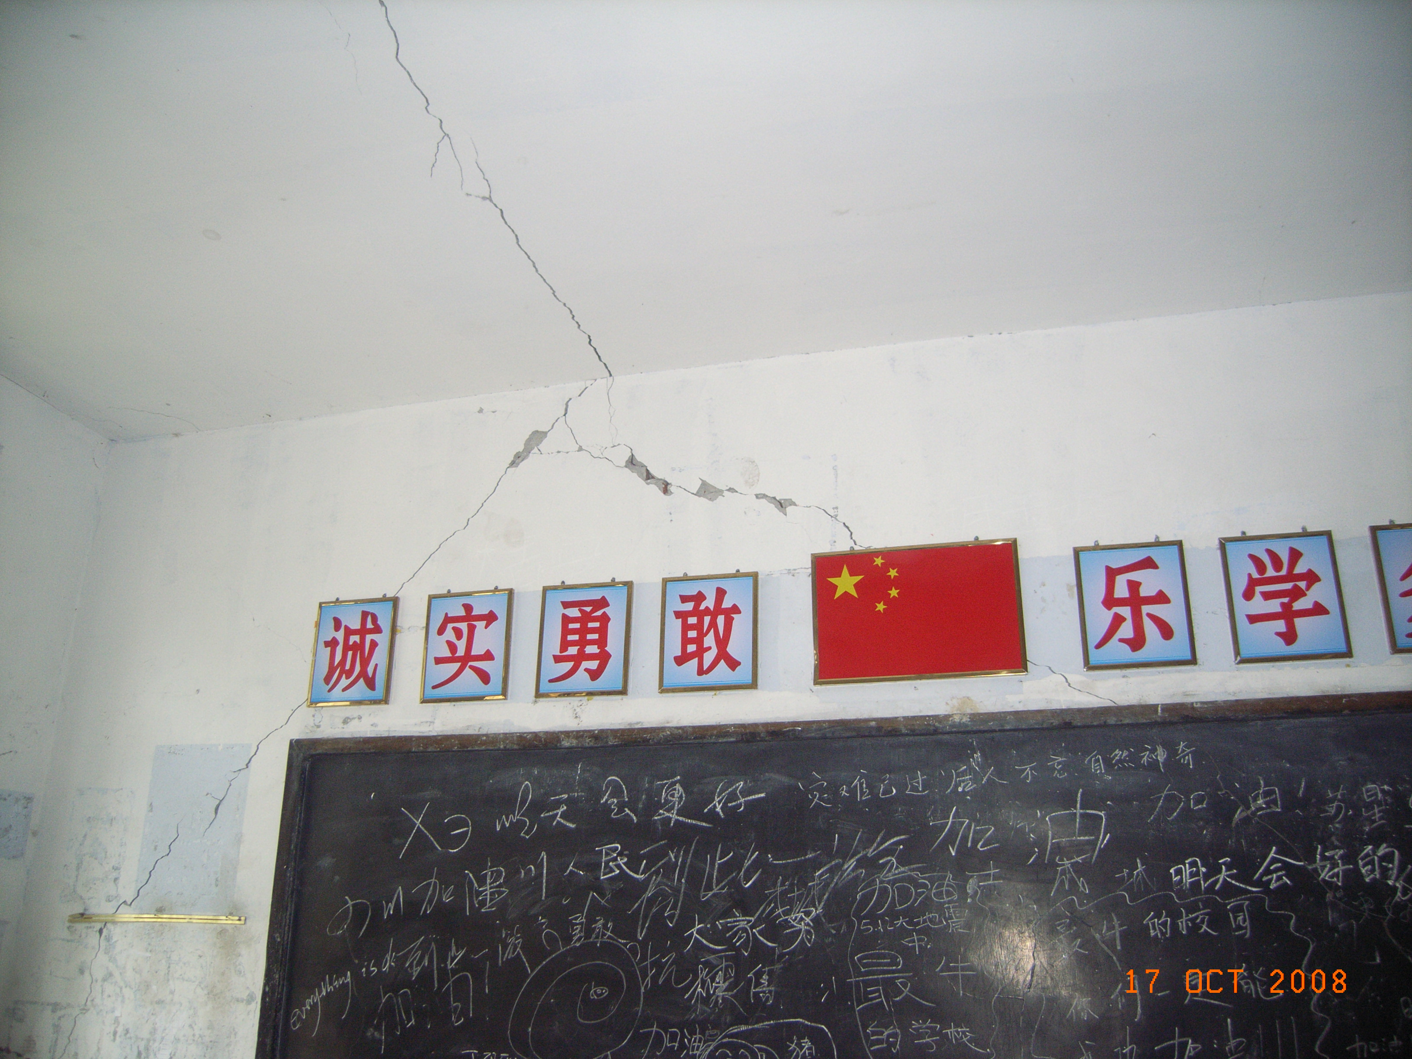**

**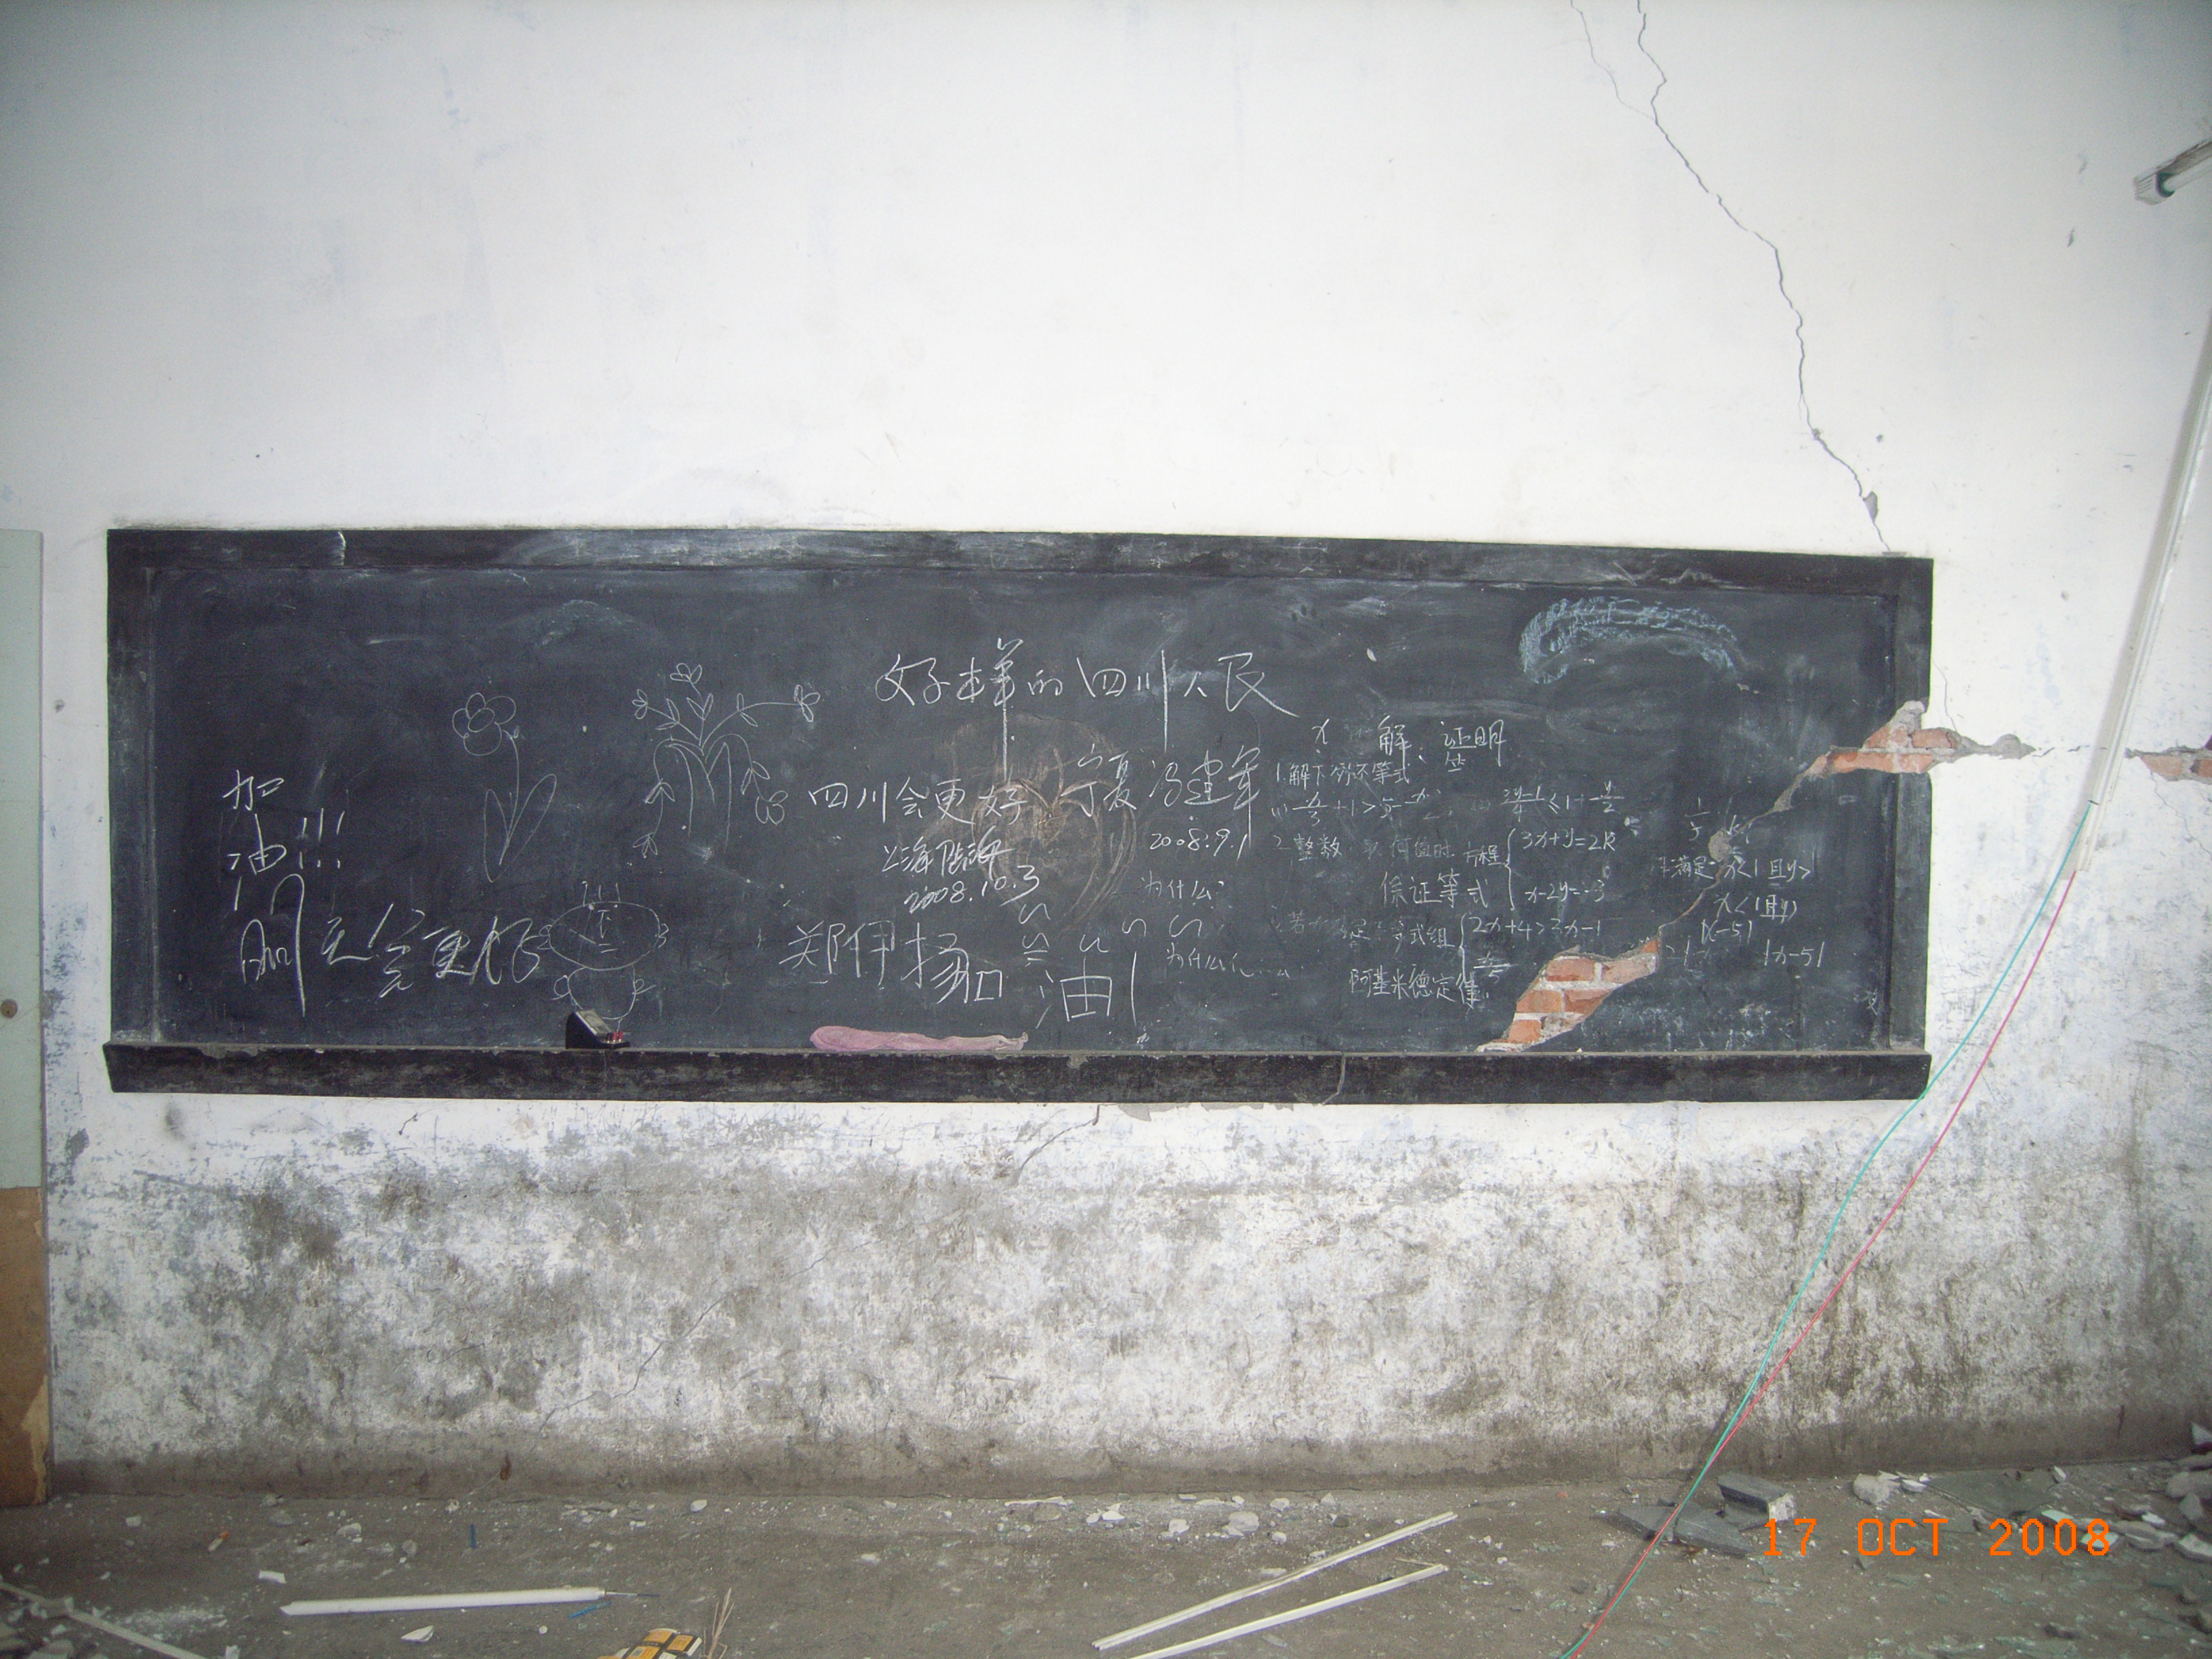**

**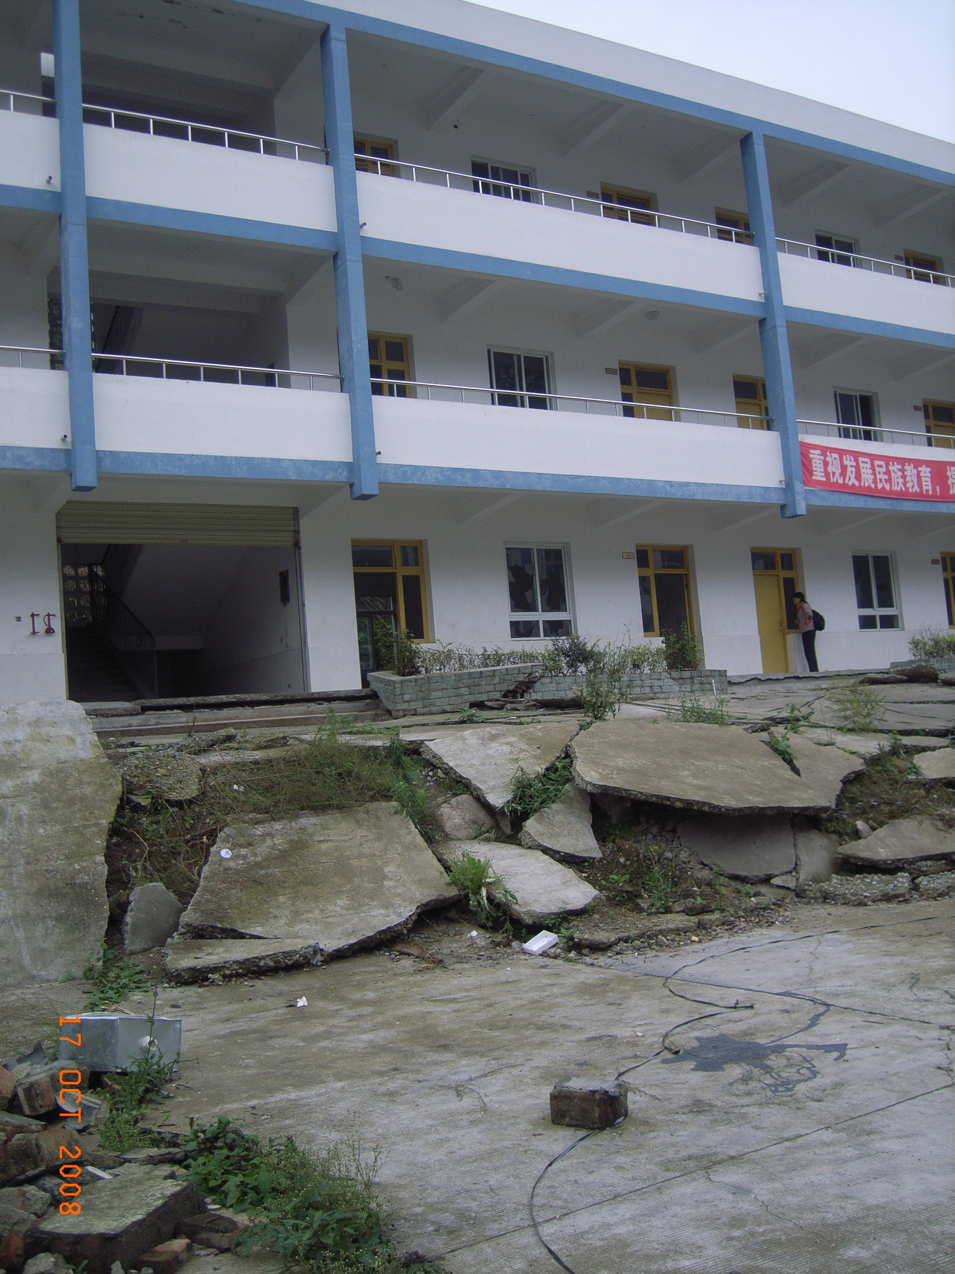**

**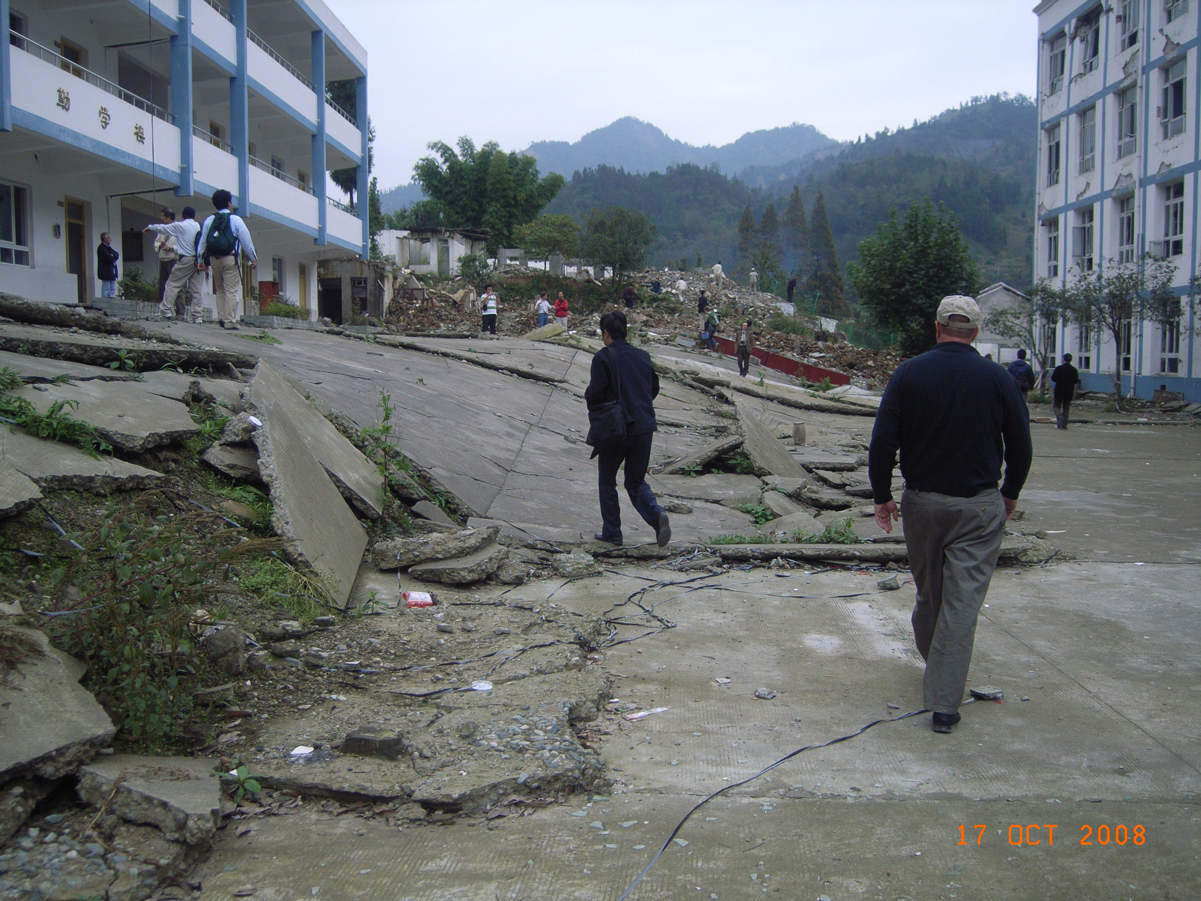**

**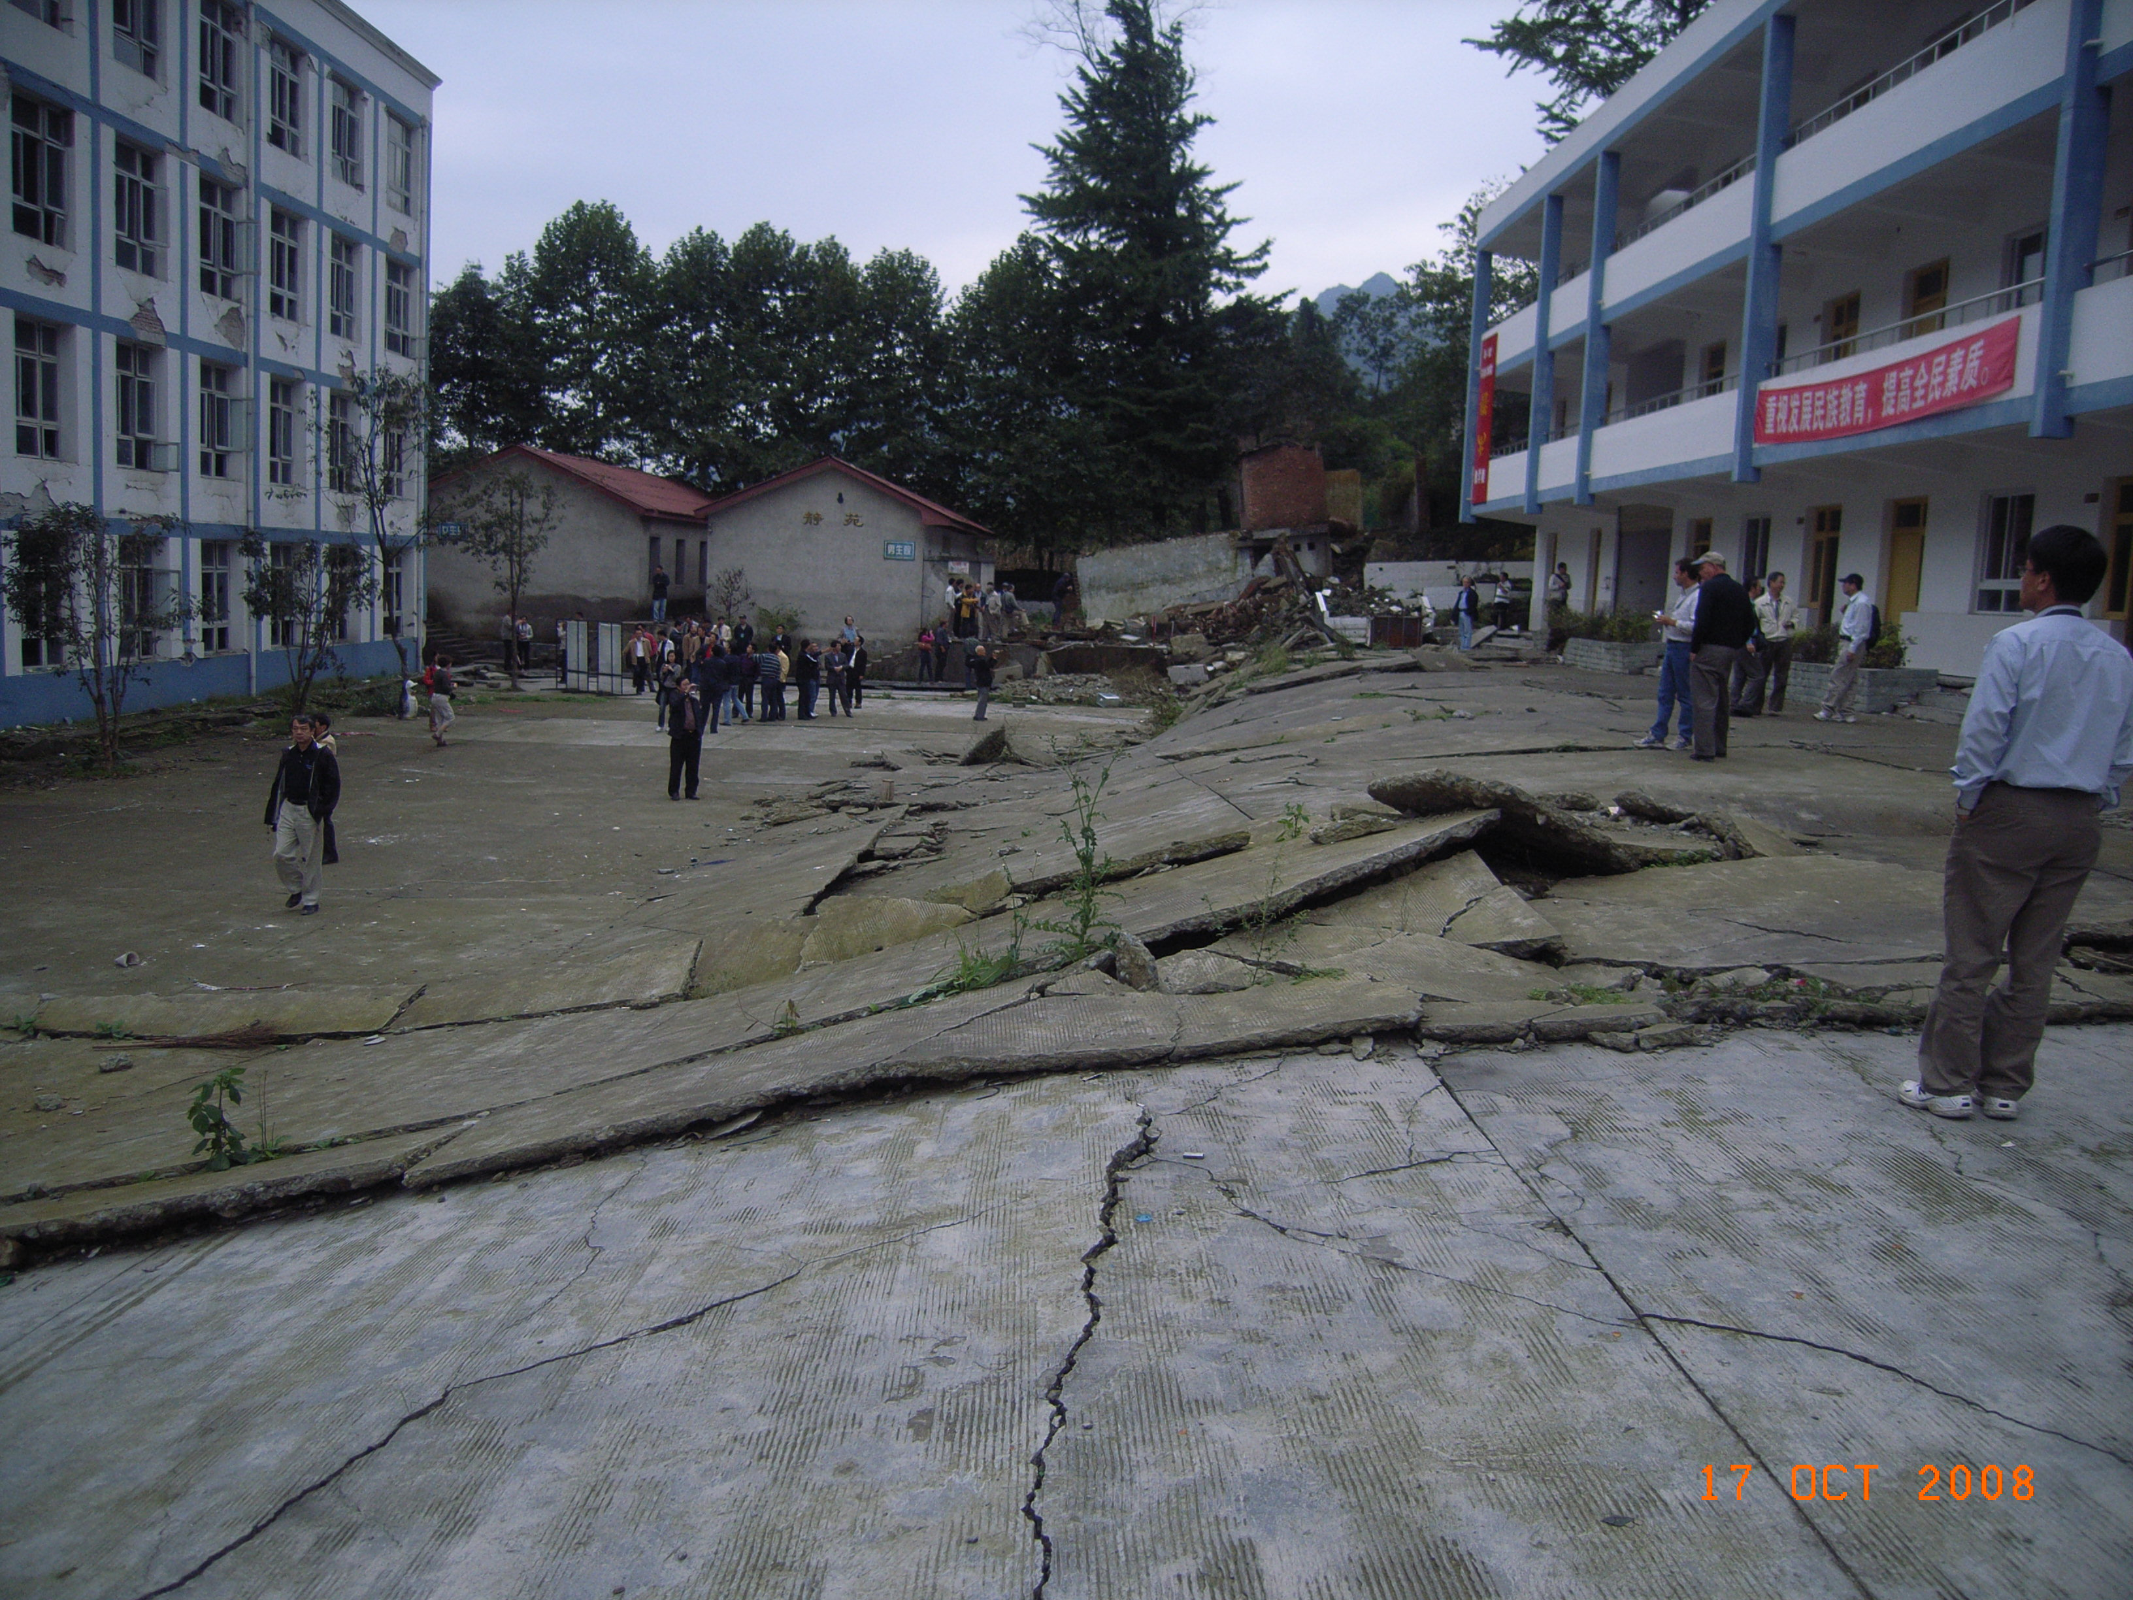**

|  |  |
| --- | --- |
| **Macintosh HD:Users:davidrobinson:Documents:datafiles:workstuff:Git_sandpit:bk:images:bailu:Photos 174.jpg** | **Macintosh HD:Users:davidrobinson:Documents:datafiles:workstuff:Git_sandpit:bk:images:bailu:Photos 194.jpg** |

**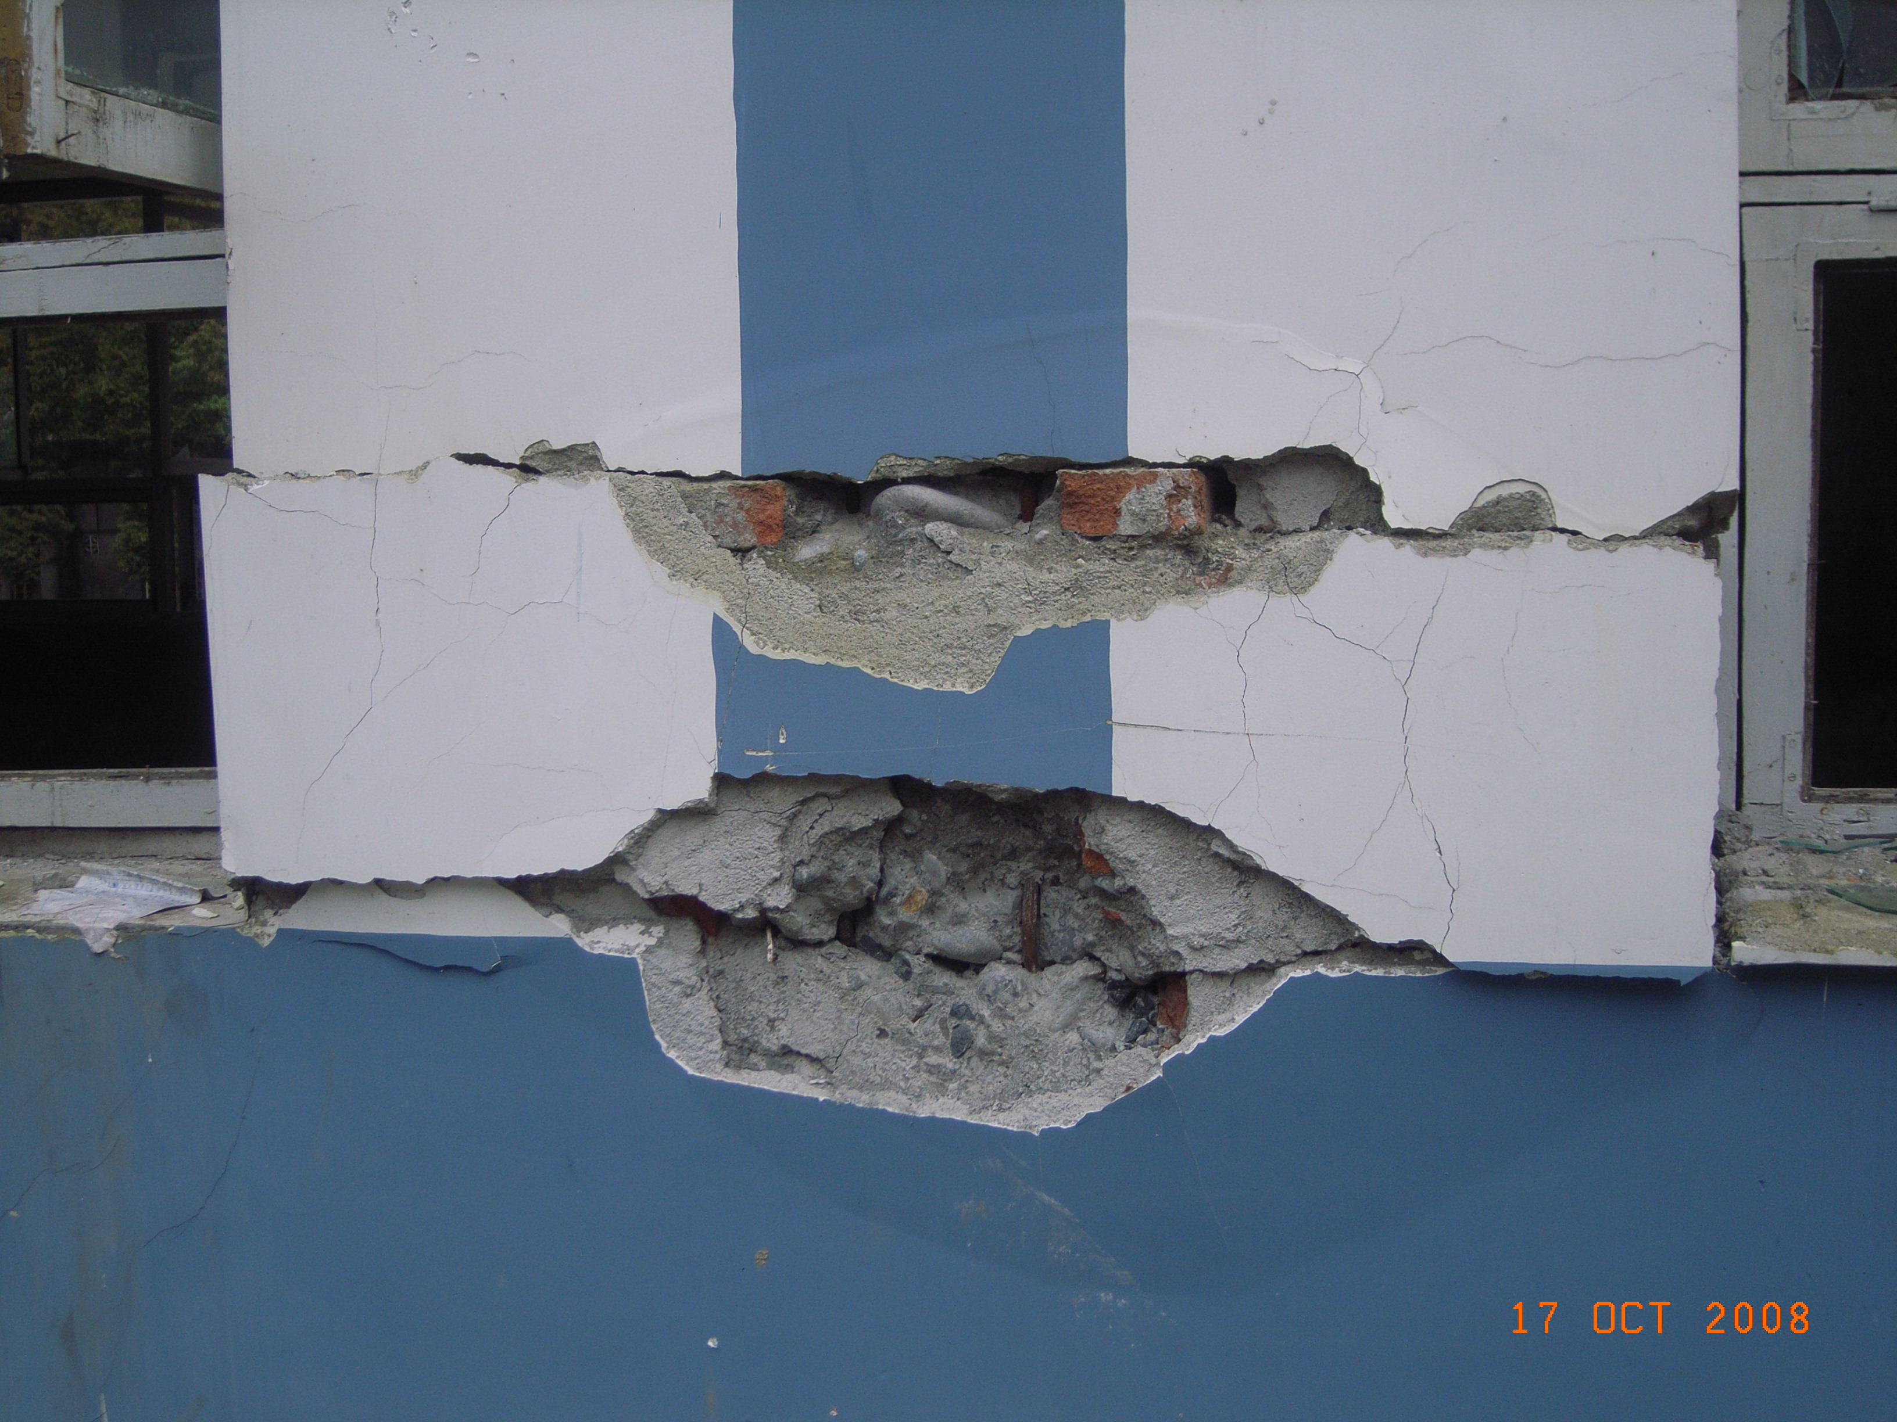**

**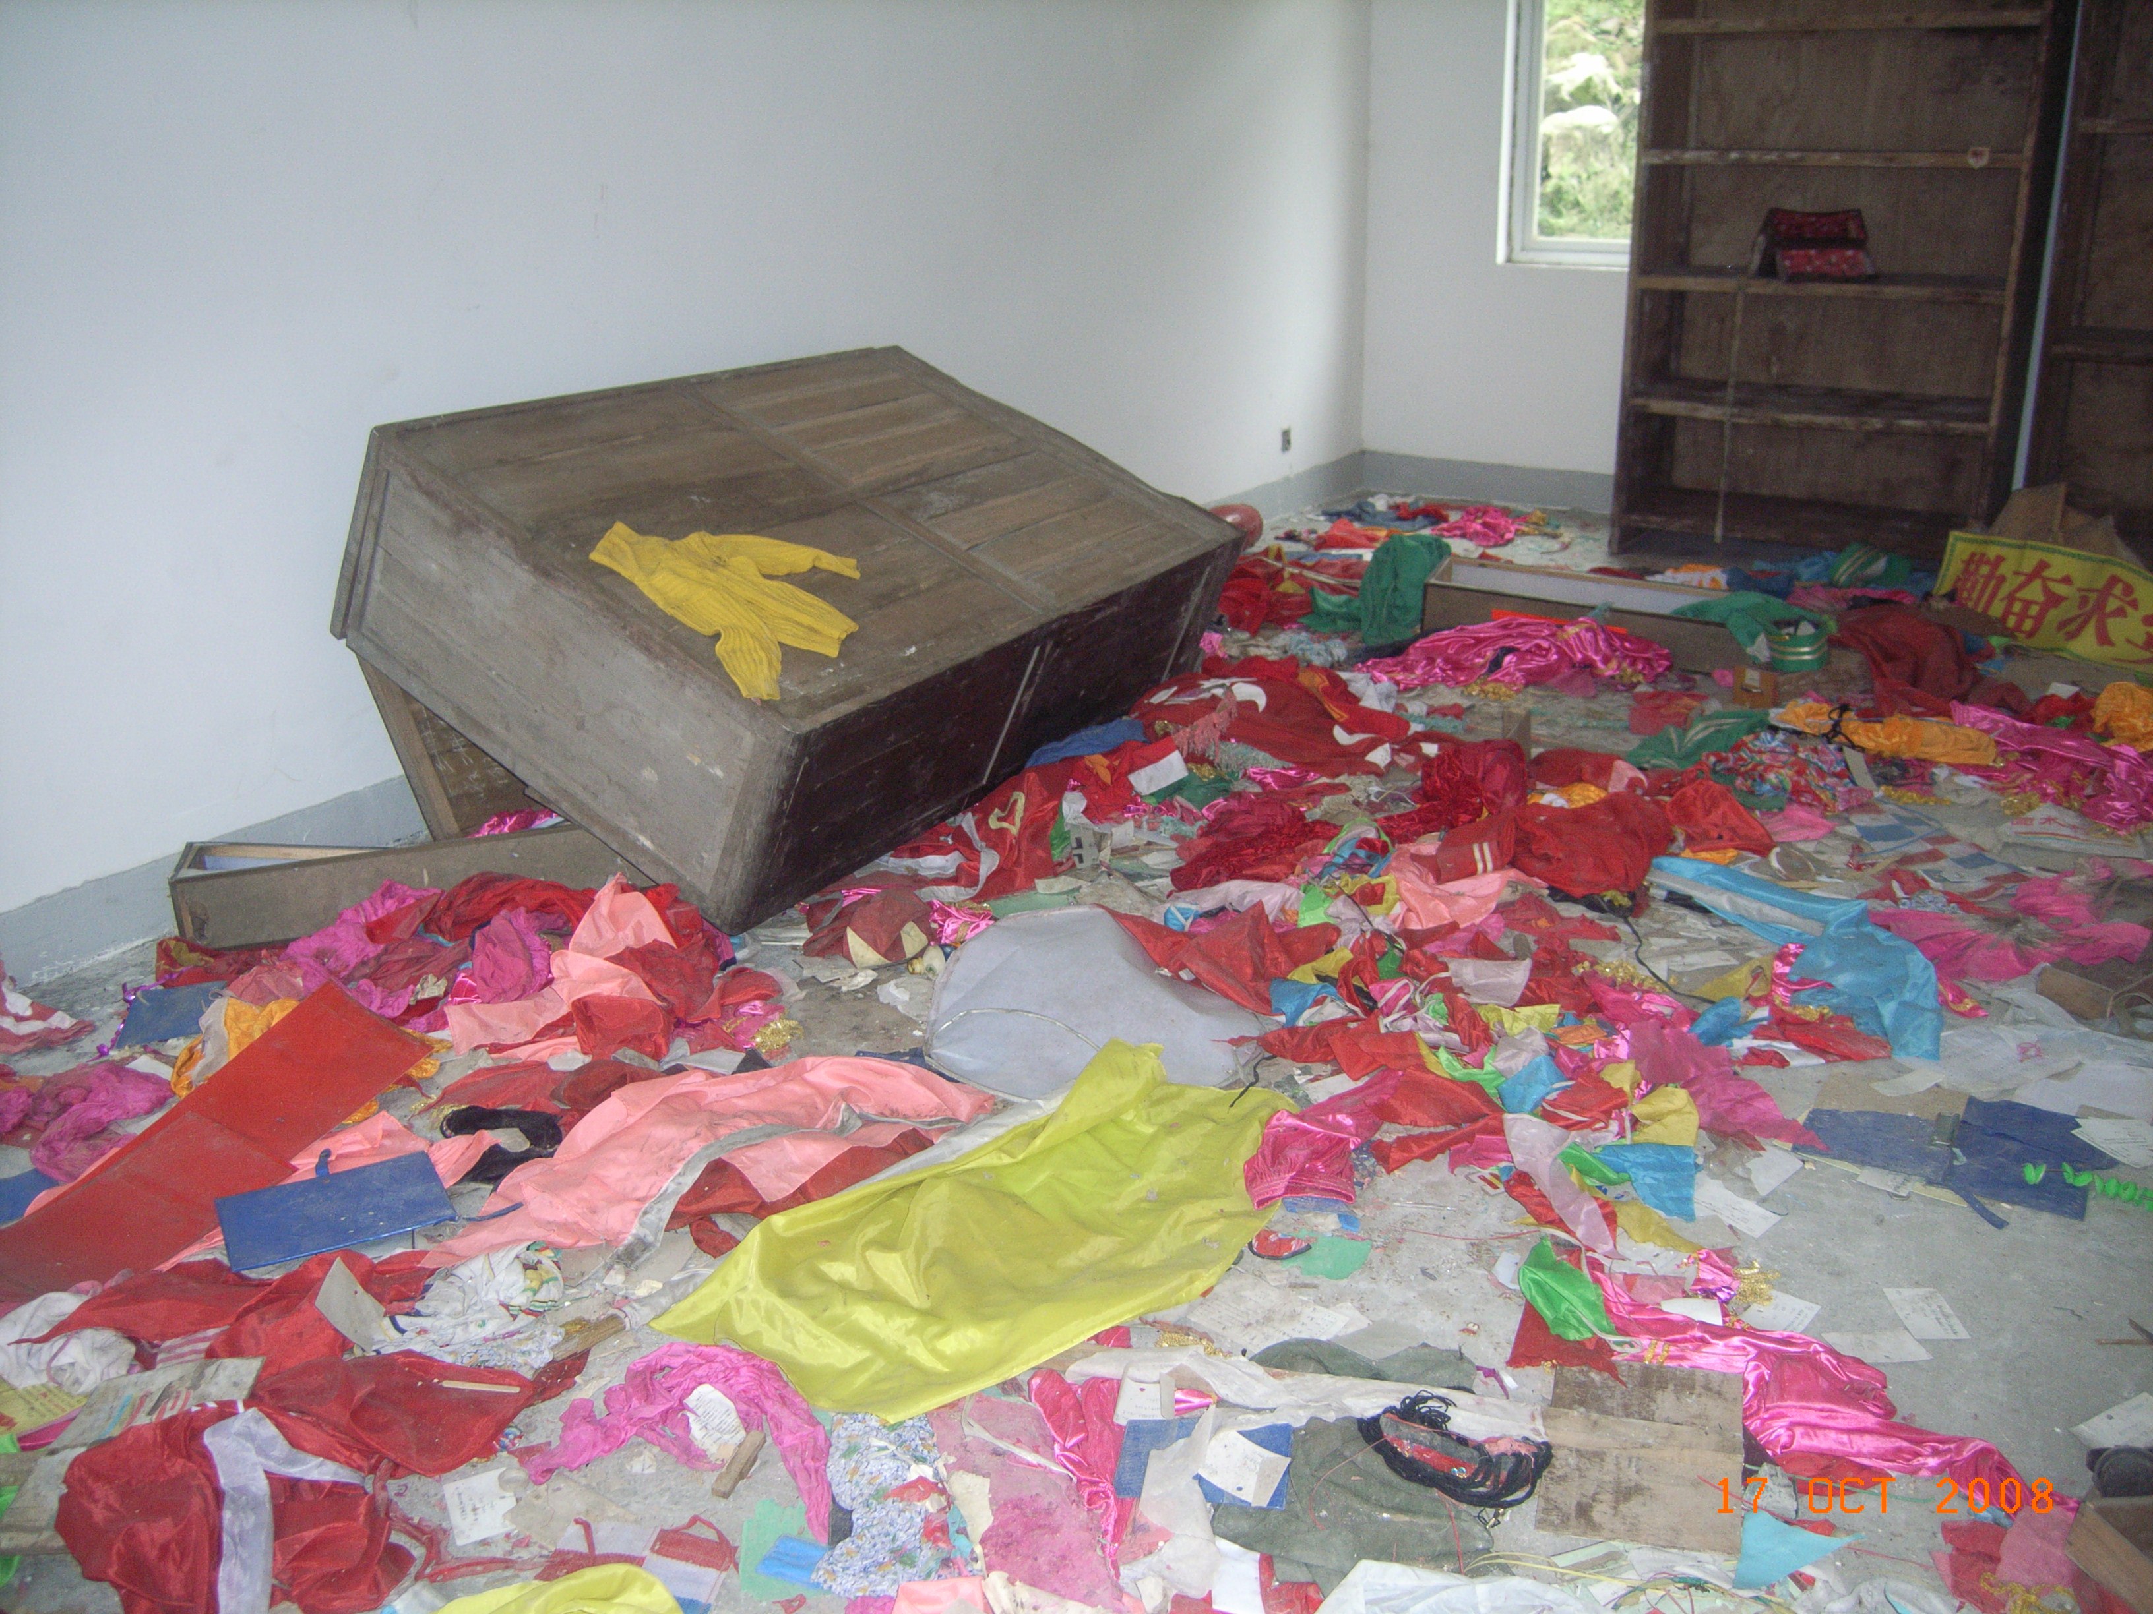**

**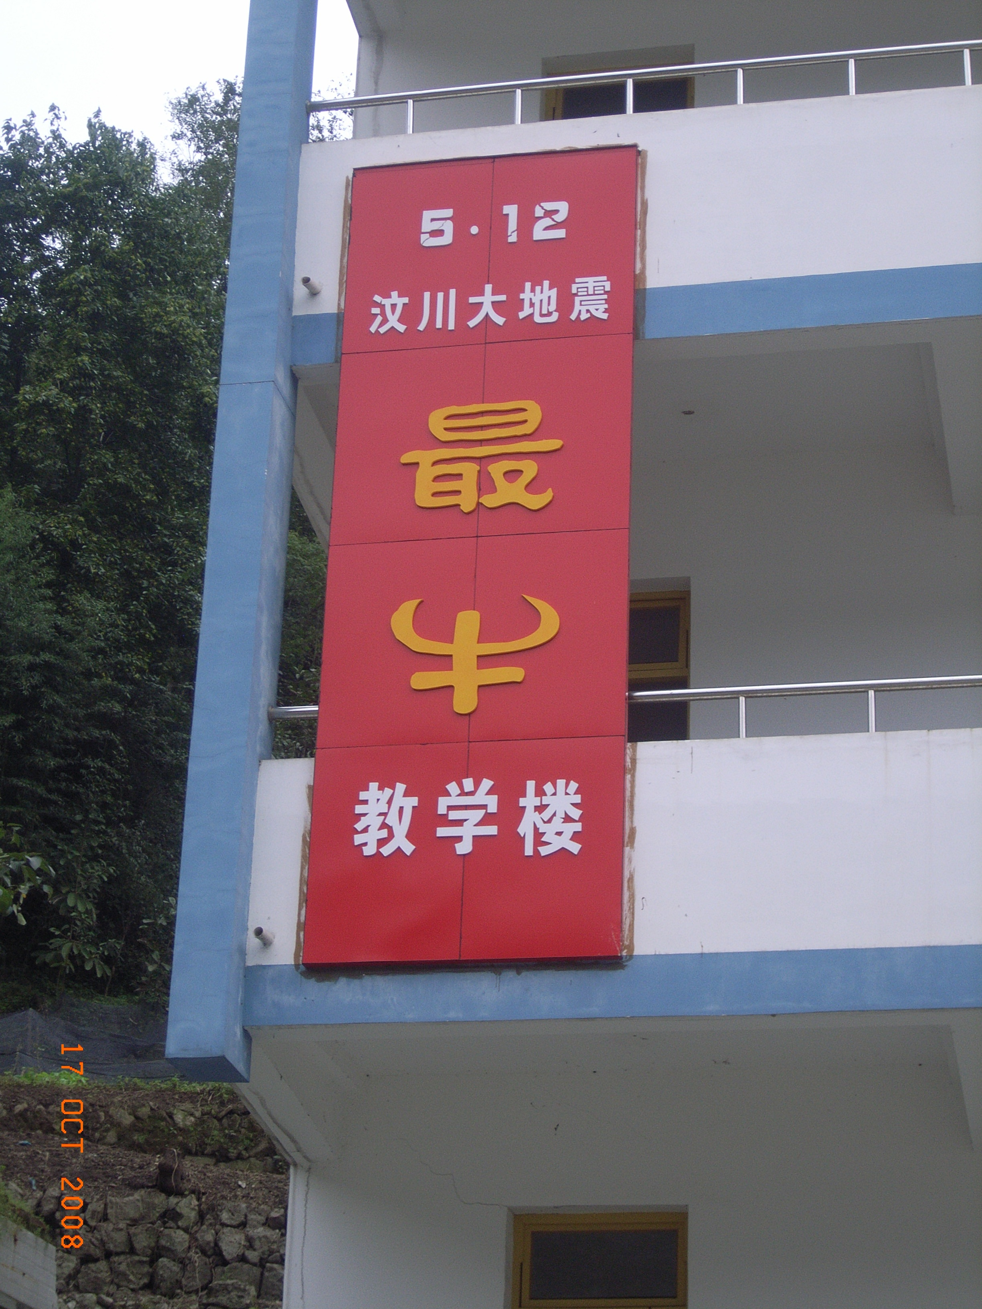**

**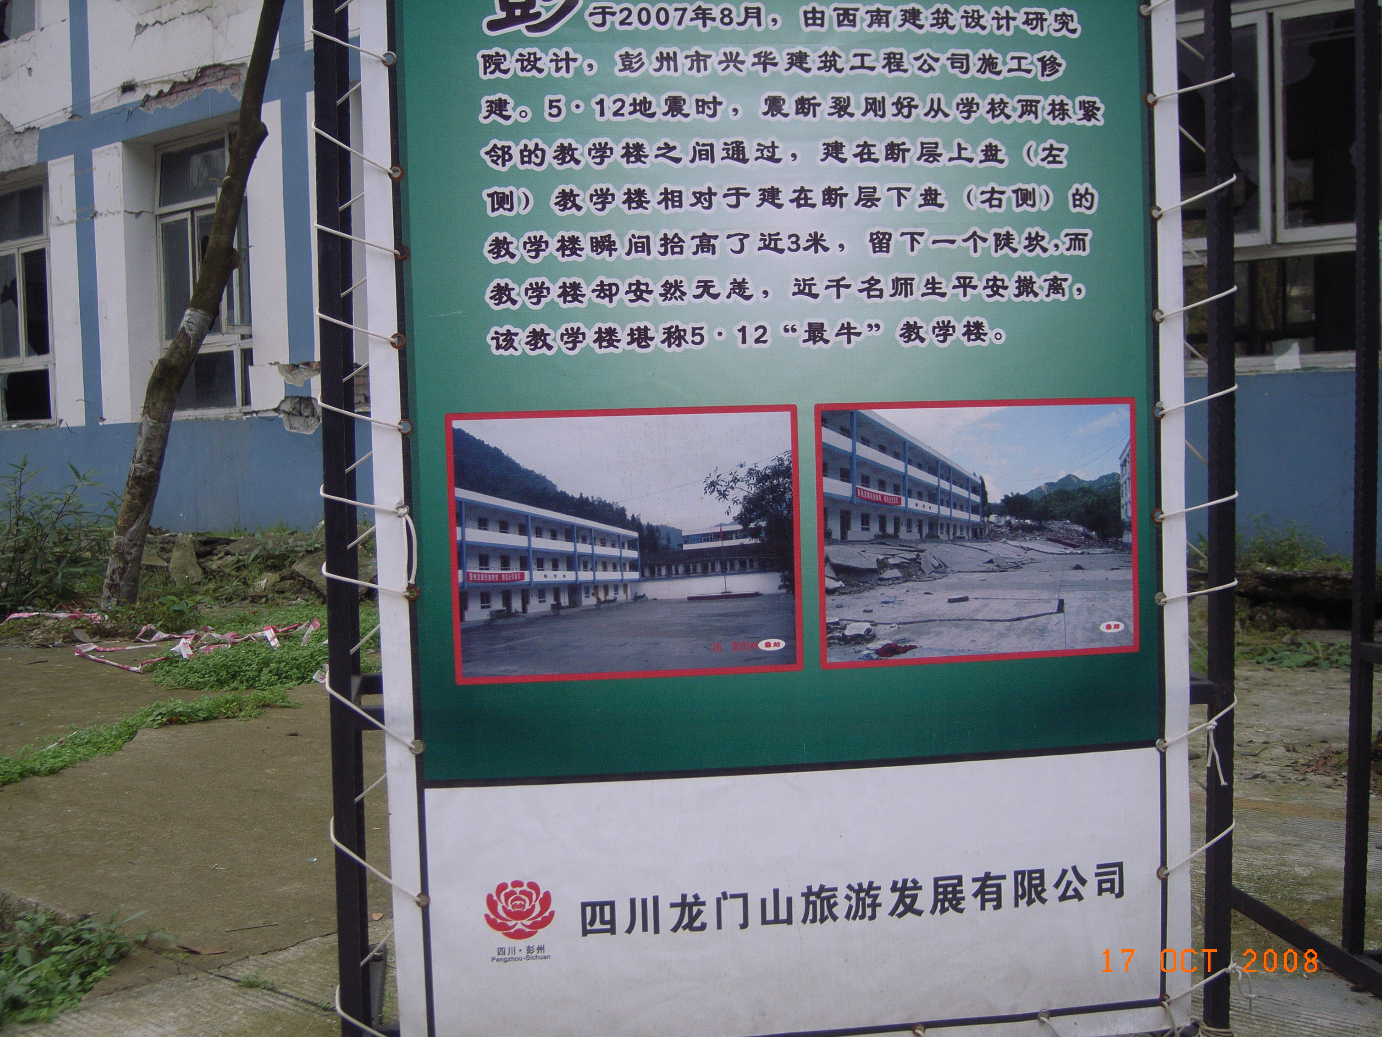**

**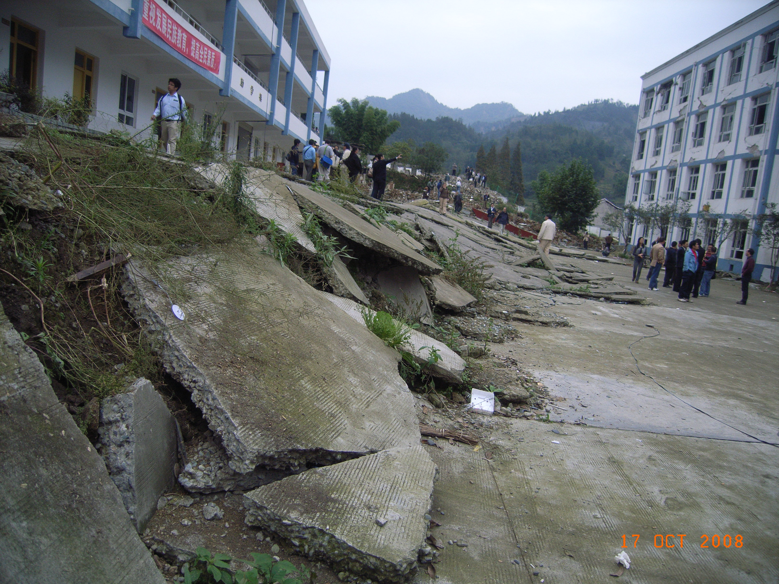**

**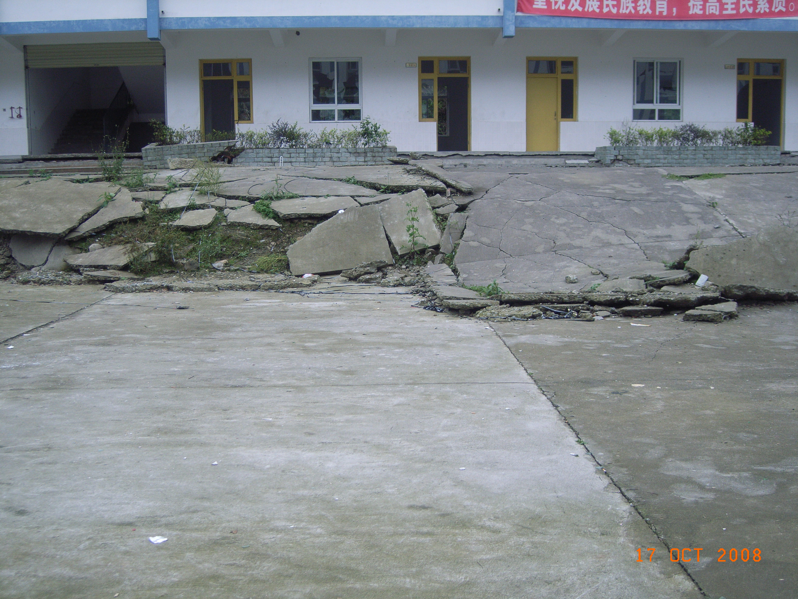**

**Clock**

|  |  |
| --- | --- |
| **Macintosh HD:Users:davidrobinson:Documents:datafiles:workstuff:Git_sandpit:bk:images:clock:RIMG0341.JPG** | **Macintosh HD:Users:davidrobinson:Documents:datafiles:workstuff:Git_sandpit:bk:images:clock:RIMG0342.JPG** |

|  |  |
| --- | --- |
| **Macintosh HD:Users:davidrobinson:Documents:datafiles:workstuff:Git_sandpit:bk:images:clock:RIMG0344.JPG** | **Macintosh HD:Users:davidrobinson:Documents:datafiles:workstuff:Git_sandpit:bk:images:clock:RIMG0343.JPG** |

**Beichuan**

**